“Virtual Realty” Enters the Arena to Help People Overcome Their Co-Dependency
on Outside Approval-- to Achieve an Emotionally Free, High Performance,
Happy Life

Groundbreaking New Offering at the Nexus of Internationally Hot Trends—Virtual Reality, Self-Help and Meditation

Acclaimed, Proven Bosurgi Method™ Works With Mobile or Desktop/Laptop Options—Pioneering Self-Help for Today’s Tech Savvy World

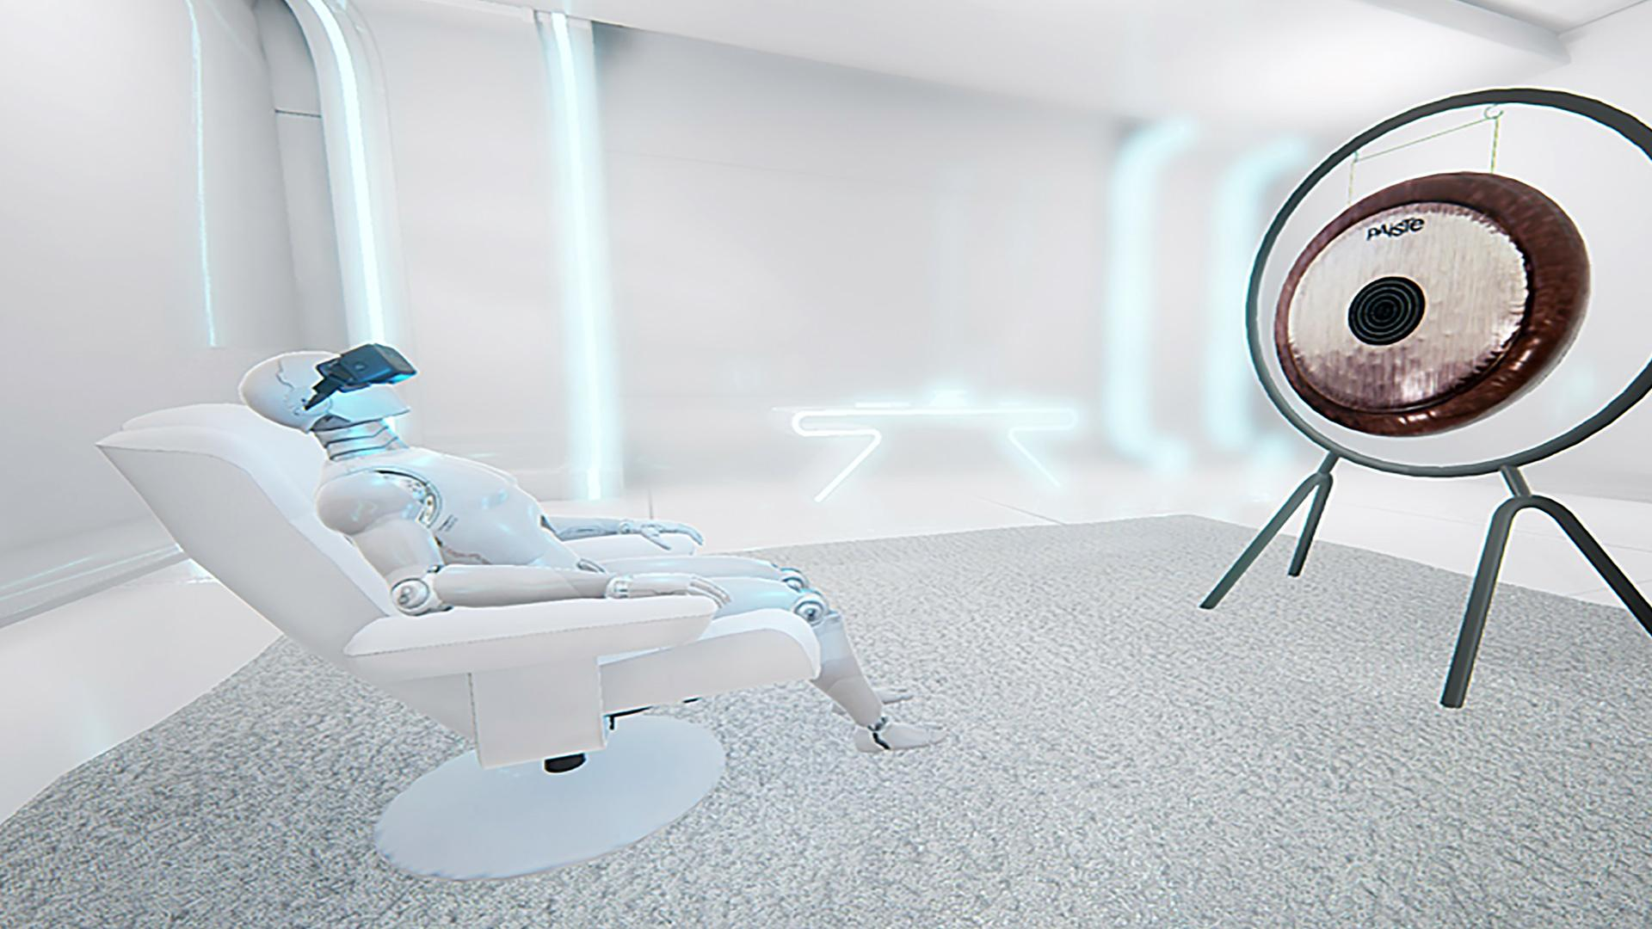
Santa Monica, CA--Until now, all the buzz around Virtual Reality has been about its entertainment and gaming applications, and even a bit of meditation. But coming to the market for the first time is a Virtual Reality product that actually helps people achieve an emotionally free, high performance, happy life—through a proven psychologically therapeutic self-help technique called The Bosurgi Method™.

The creators, a Silicon Beach company called Mind Fitness Labs, are breaking new ground by applying VR to the first self-help product, using guided meditations. And while this product guides its users into a meditative state, it goes well beyond simple meditation to release a person’s co-dependency on outside approval—creating emotional maturity and psychological independence. Co-dependency can take the form of:
- Low self-esteem, self-judgement and never feeling “enough”
- Wanting to find one’s happiness, love and approval in others (parents, lovers, spouses, friends, society, etc)
- Fearfulness including being afraid of rejection, fear of making life’s big decisions, reluctance to move forward, work life malaise, etc.
- Varying levels of anxiety, including fear
- Addictions
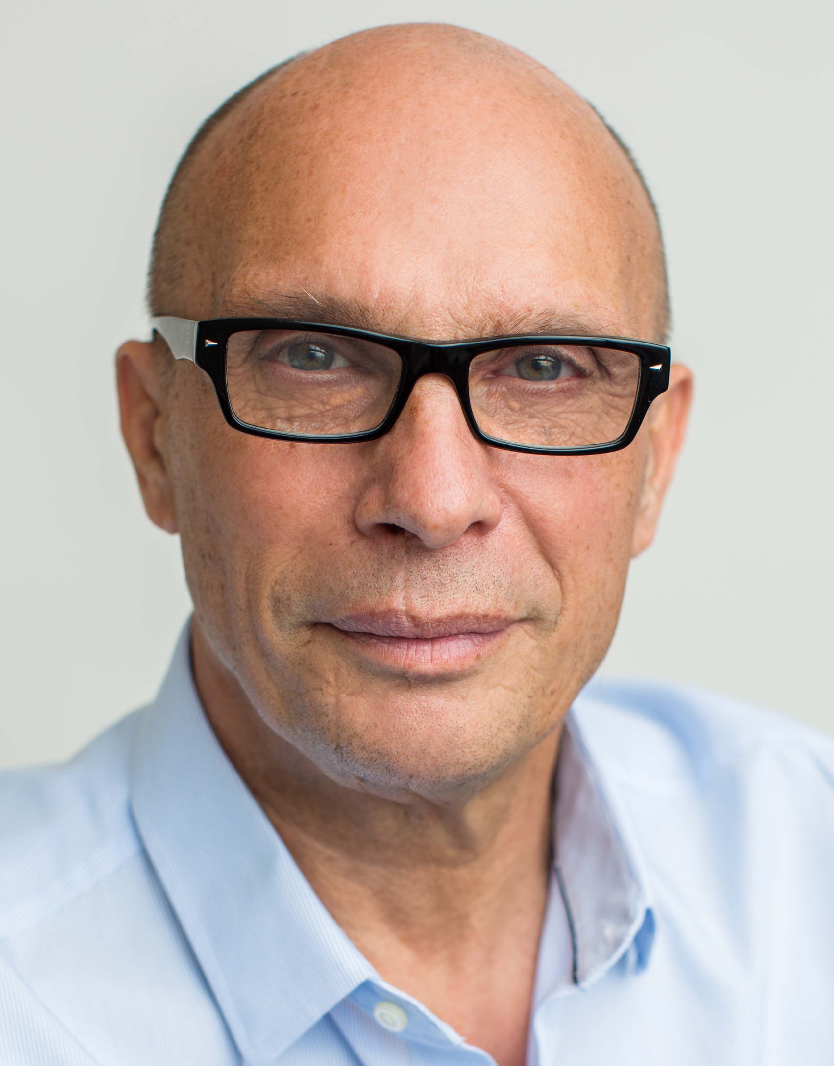
The Bosurgi Method™ is the lifetime work of Luca Bosurgi, Mind Fitness Labs founder, clinical hypnotherapist, and visionary pioneer in guided imagery for therapeutic health. A successful investment banker, venture capitalist and member of an elite Italian dynasty, Bosurgi left behind the financial world 10 years ago to devote himself exclusively to his lifelong passion--creating a means to free mankind from its self-imposed mind misery and self-destructive habits.

The result was The Bosurgi Method™, which over the past four years, has achieved a constant 95% success rate using a talk therapy process, beginning with 10 core meditations. The Bosurgi Method™ helps people improve their lives in two very disruptive ways:
(1) It improves the mind’s ability to manage thoughts, emotions and feelings, to increase productivity, ultimately enhancing overall efficiency and happiness. (2) It re-defines of the mind’s emotional management, allowing for the re-wiring of past behaviors with more efficient and effective new behaviors.

“The Bosurgi Method puts people in control of their thoughts, feelings and emotions, disentangling their survival system from learned behaviors that are born out of insecurity and emotional dependency, the primary cause of psychological dysfunction that millions face today,” says Bosurgi, Mind Fitness Labs’ CEO.
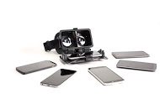
This acclaimed, proven system—embraced by individual clients internationally and therapists alike—has now been adapted to Virtual Reality, with effectively equivalent results in testing. Thanks to such advancements as high quality VR goggles, the sophistication of computer graphics, and the exponential growth of the mobile marketplace, The Bosurgi Method™ can now pioneer self-help for today’s tech savvy world.

Those wishing to avail themselves of The Bosurgi Method’s Mind Fitness Virtual Reality product may choose a fully mobile solutions available through a downloadable mobile app or desktop/ laptop option. Currently available for Android and Apple phones, the app can be found by searching “My Mind Fitness.” in your App-Store. To access the full product array online, go to www.MindFitnessLabs.com.

Users have the option to select the 10 Core Meditations, plus 10 interim meditations with or without VR goggles.
- Without goggles, the MSRP is $299
- With Merge VR Smartphone 3D Headset, the MSRP is $399
- With Desktop/Laptop Goggles, {Contact Mind Fitness Lab for Pricing}

In the mobile applications, the user queues up the meditation in the Mind Fitness Labs application and inserts the phone into the VR headset.

The Bosurgi Method™ 10 Core Meditations include the following modules:
1. Release anxiety and fears I
2. Release anxiety and fears II
3. Release dependency behaviors I
4. Release dependency behaviors II
5. Release dependency behaviors III
6. Build framework master behavior of independence I
7. Build framework master behavior of independence II
8. Release self-judgment, shame, guilt and regret (self-forgiveness)
9. Release judgment, blame, resentment, anger and pain (forgiveness others)
10. Release anxiety and fears III

Also included are 10 interim meditations, to be experienced after each Core Meditation, with a purpose of enhancing the results of the core meditations.

Also included is a full suite of Mind Fitness resources, available online and using the app. Among them are goal-setting and progress-tracking features, performance-based awards and inducements, social networking integration if desired, and a store to purchase more advanced modules and other products.

While meditation and other low-cost apps may be readily on the market, this product differs significantly in that it provides a life-changing technique that accelerates a process otherwise achieved in a therapeutic setting with a trusted counselor. And it does it, for the first time, in the all-immersive home-based experience of Virtual Reality. And, in fact, Mind Fitness Labs has begun partnering with psychologists nationwide to help them improve the speed of results with clients using these new products.

“The Bosurgi Method is Mind Fitness Labs’ opening offering in a commitment to bringing life-changing, technologically-delivered, products focused on mental and emotional health forward to enhance people’s quality of life and happiness,” states Ivan Klarich, the company’s President.

To see more or to experience the Virtual Reality impact of The Bosurgi Method™, visit www.MindFitnessLabs.com.

Products:

The Bosurgi Method™

All Initial Products Come With:

The Bosurgi Method™ 10 Core Meditations (listed here) + 10 Interim Meditations:
1. Release anxiety and fears I
2. Release anxiety and fears II
3. Release dependency behaviors I
4. Release dependency behaviors II
5. Release dependency behaviors III
6. Build framework master behavior of independence I
7. Build framework master behavior of independence II
8. Release self-judgment, shame, guilt and regret (self-forgiveness)
9. Release judgment, blame, resentment, anger and pain (forgiveness others)
10. Release anxiety and fears III

- 20 Meditations without VR Goggles (VR Goggles are required to play sessions) $299

- 20 Meditations with Merge Virtual Reality Smartphone 3D Headset
$399
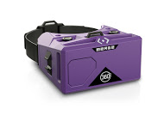

- 20 Meditations with Oculus Rift Goggles (Desktop/Laptop) Contact Mine Fitness Lab
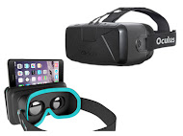

Luca Bosurgi
Mind Fitness Lab CEO and Founder
Creator of The Bosurgi Method™

Luca Bosurgi was born to an Italian Aristocratic family in Rome, Italy, descendants of the Marquis Bosurgi with a 1,200 history rich in art, engineering and enterprise. In 1850, Luca’s grandfather invented concentrated orange juice, establishing himself as one of the first Italian Industrialists.
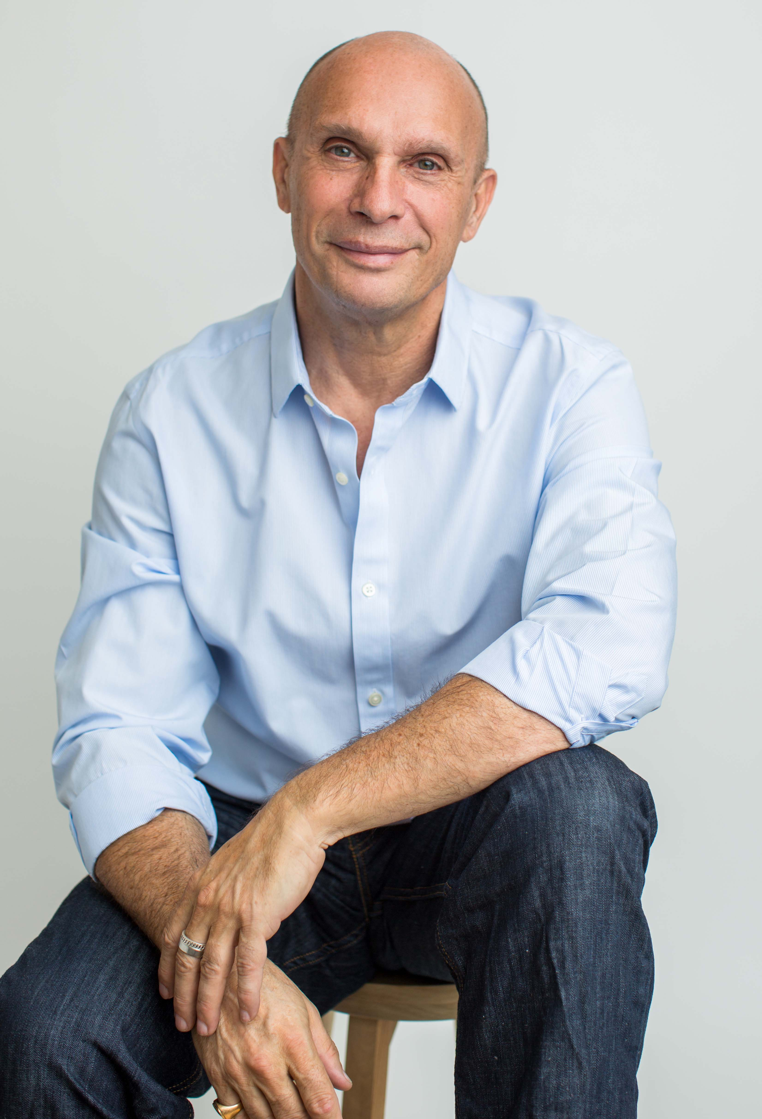
Luca’s history is an eclectic mix of experiences that meshes perfectly with his passion to increase human happiness and self-reliance. At an early age, Luca began receiving extensive spiritual teachings from a channeled holy master. By the time he was becoming an adult, Luca had acquired groundbreaking knowledge about the meaning of life, the spirit-mind hierarchy, the mechanics of the mind and how it relates to mankind’s journey of spiritual evolution.
At 23, Luca was called on to rescue his family company, Sanderson & Sons in Messina, Sicily. In three years, Luca saved 1,500 jobs and secured the continued production of approximately 25,000 citrus farmers. This experience launched Luca into his first career, investment banking.
At 28, Luca established his investment portfolio in Luxemburg with offices in London and New York. His company focused on portfolio management, VC investments and M&A. In the 2005, after more than two decades of sharing his life between his healing mission and the world of banking, he sold his business and moved to Los Angeles to establish his Bosurgi Method™ School and Los Angeles practice. This began Luca’s 10-year-long journey towards perfecting the first three phases of the Bosurgi Method, and has allowed him to enhance and refine his method--improving his success rate from the initial 65% to more than 95% in the last four years. Today, thousands of people have experienced the Bosurgi Method, not only with Luca, but also with the approximately 20 mind healers that he has trained.
In 2014, Luca identified Virtual Reality as an effective channel to bring the Bosurgi Method™ to the general public. This motivated him to build a team and, based on the Bosurgi Method, develop a Virtual Reality Mind Training solution. The efficacy of using VR as a delivery mechanism for the Bosurgi Method was tested and proven out in beta testing, showing results that equaled those he obtained in his practice – exceeding 95%.
In 2015, following his vision to create a higher performing, emotionally independent and happy world, Luca founded Mind Fitness Lab, a portfolio company established to invest, develop and distribute disruptive mind solutions. The Bosurgi Method™ is now the first product developed and distributed by the Mind Fitness Lab Corporation.

Additionally, Luca is highly trained in ancient combat and martial arts (black belt in judo and karate), and initiated in Western and Easter mind-body disciplines, as well as Native American teachings. Luca consistently seeks effective ways to impart greater balance and healing to those in need. He discovered the power of Clinical Hypnosis in the early 1990’s in London. He was individually trained by Michael Joseph, founder and President of the British Society of Clinical Hypnosis and publisher of the European Journal of Clinical Hypnosis. Clinical Hypnosis, combined with his comprehensive knowledge of computer and digital science, metaphysics, psychology and ancient mind/spirit healing techniques, became the foundation of Luca's new form of psychotherapy, the Bosurgi Method™.

Luca lives with his wife and three children in Santa Monica, California.

Ivan Klarich
Mind Fitness Labs President

Ivan Klarich joined Mind Fitness Labs to bring his expertise as a leading corporate strategist and business leader to the embryonic company, to create a foundation for rapid growth. He is a results-driven executive with a successful 20+ year track record as an advisor to fortune 500 companies, small-to- medium-sized businesses, start-ups and investment groups. One of his greatest strengths is “big-thinking strategy,” looking far ahead to make the right moves today.
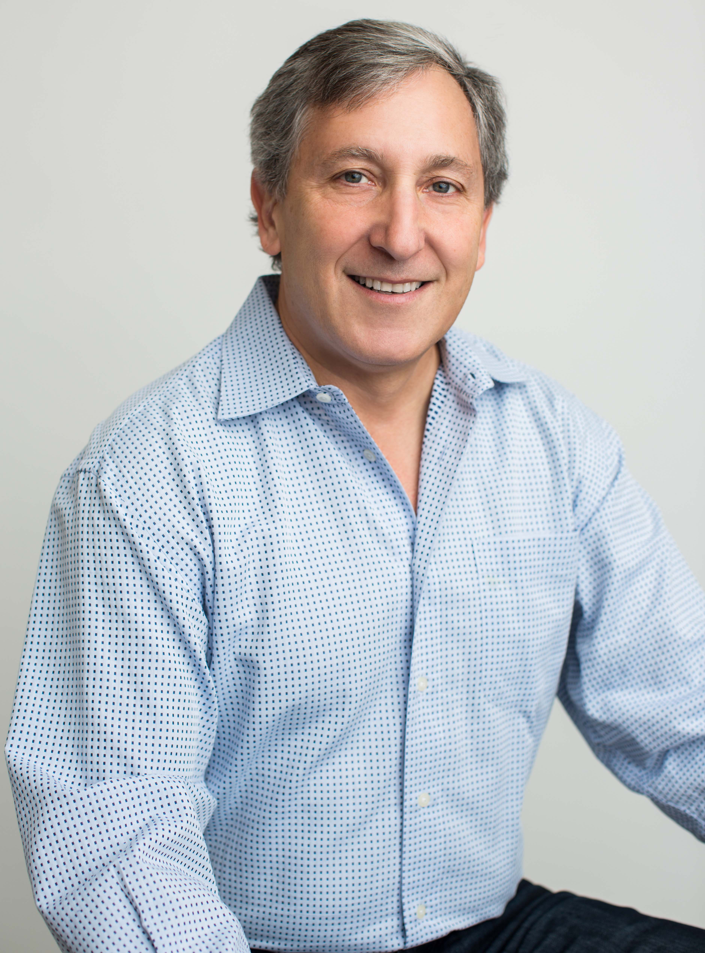
Ivan has a distinct ability to quickly convert strategic thinking into tactical plans that can be efficiently implemented. Having a keen eye for spotting and preventing problems before they develop and for leading pro-active, insightful teams, he is a sought- after CEO, Board Member and turnaround artist. He has a proven ability to attract financing, lead successful business development campaigns, and identify new and expanded revenue generation opportunities.
Ivan has brought his skills to a variety of companies in transition and worked with investors in pre-investment analysis, operational restructuring and restructuring for M&A. Additionally, he has built and run his own professional service and consulting companies, as well as a high-end web development and digital marketing firm.

Media Introductions

Luca Bosurgi
Mind Fitness Lab CEO and Founder
Creator of The Bosurgi Method™

Until now, all the buzz around Virtual Reality has been about its entertainment and gaming applications, and even a bit of meditation. But coming to the market for the first time is a Virtual Reality product that actually helps people achieve an emotionally free, high performance, happy life—through a proven psychologically therapeutic self-help technique called The Bosurgi Method™. This process, using guided meditations, releases a person’s co-dependency on outside approval—creating emotional maturity and psychological independence. Co-dependency can take the form of:
- Low self-esteem, self-judgement and never feeling “enough”
- Wanting to find one’s happiness, love and approval in others (parents, lovers, spouses, friends, society, etc)
- Fearfulness including being afraid of rejection, fear of making life’s big decisions, reluctance to move forward, work life malaise, etc.
- Addictions

The success rate of The Bosurgi Method™ is consistently more than 95%. And now marrying three of the hottest trends in the world today—virtual reality, self-help and meditation—people can now experience this therapeutic technique as a breakthrough mind training sensory experience, courtesy of Mind Fitness Labs.

With us today is Luca Bosurgi, Mind Fitness Labs founder, clinical hypnotherapist, and visionary pioneer in guided imagery for therapeutic health through Virtual Reality. A succesful investment banker, venture capitalist and member of an elite Italian dynasty, Bosurgi left behind the financial world 10 years ago to devote himself to his lifelong passion--creating a means to free mankind from redudant mind misery.

Ivan Klarich
Mind Fitness Labs President

Until now, all the buzz around Virtual Reality has been about its entertainment and gaming applications, and even a bit of meditation. But coming to the market for the first time is a Virtual Reality product that actually helps people achieve an emotionally free, high performance, happy life—through a proven psychologically therapeutic self-help technique called The Bosurgi Method™. This process, using guided meditations, releases a person’s co-dependency on outside approval—creating emotional maturity and psychological independence. Co-dependency can take the form of:
- Low self-esteem, self-judgement and never feeling “enough”
- Wanting to find one’s happiness, love and approval in others (parents, lovers, spouses, friends, society, etc)
- Fearfulness including being afraid of rejection, fear of making life’s big decisions, reluctance to move forward, work life malaise, etc.
- Addictions

The success rate of The Bosurgi Method™ is consistently more than 95%. And now marrying three of the hottest trends in the world today—virtual reality, self-help and meditation—people can now experience this therapeutic technique as a breakthrough mind training sensory experience, courtesy of Mind Fitness Labs

With us today is Mind Fitness Labs’ President Ivan Klarich who has partnered with The Bosurgi Method™ creator Luca Bosurgi to bring this innovation to market. Ivan, a leading corporate strategist and business leader, has come on board to create a foundation for rapid growth. He is a results-driven executive with a successful 20+ year track record as an advisor to fortune 500 companies, small-to- medium-sized businesses, start-ups and investment groups.

Ivan is himself a powerful advocate for The Bosurgi Method™, seeing the vast impact he believes this new Virtual Reality product can have to change millions of people’s lives -- and as an executive who sees an unlimited future for the company that pioneers personal growth via the immerse VR experience.

Questions for Mind Fitness Labs Interviews

- Why is this application of Virtual Reality so a groundbreaking?
- What is The Bosurgi Method™?
- How did The Bosurgi Method™ come to be?
- Why is The Bosurgi Method™ so effective?
- Why do you call the company Mind Fitness Labs?
- Who is a candidate to use this?
- Discuss the different ways one can access The Bosurgi Method™ through Virtual Reality? I understand you can do this online or with an app on your phone...
- What equipment is required to get optimum value of this mind fitness program?
- What do people experience when they are in the Virtual Reality world of The Bosurgi Method™?
- What are the costs involved?
- How are people responding to this Virtual Reality product?
- Why is the timing of this so perfect?
- With so many companies now offering Mindful Meditation programs, is this something that would also be beneficial?
- Is this something that can be used in conjunction with psychotherapy?
- How big do you think the market will be for this product?
- Where can people learn more about The Bosurgi Method™ and Mind Fitness Labs?

More In Depth Questions on The Bosurgi Method™

- Why did you focus on emotional co-dependency?
- How did this therapeutic process develop?
- There are lots of spiritual gurus, healers and personal growth experts offering their products and processes in the world – why is this different?
- What are some of the key components of The Bosurgi Method™ and what do they help people achieve?
- What are some examples of life-changes that you have seen in people who have used this method? Can you give us some case histories?

